COSC 4330/5330
Multimedia Processing

Instructor: Prof. JIANGJIANG (JANE) LIU

Homework 2

Andrew Kalathra
9/23/2024

- 3.4 (For Programs - use Filename, YourNameChapter3Q4, for source code and screenshot of outputs)
  - 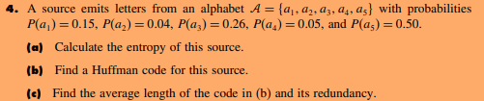
  - A. Entropy
    - H = ∑ [ P(a) * log₂(1/P(a)) ]
    - = [0.15 * log₂(100/15)] + [0.04 * log₂(100/4)] +[0.26 * log₂(100/26)] +[0.05 * log₂(100/5)] +[0.5 * log₂(10/5)]
    - = [0.15 * 2.737] + [0.04 * 4.644] + [0.26 * 1.9434] + [0.05 * 4.322] + [0.5 * 1]
    - = [0.15 * 2.737] + [0.04 * 4.644] + [0.26 * 1.9434] + [0.05 * 4.322] + [0.5 * 1]
    - = [0.41055] + [0.18576] + [0.505284] + [0.2161] + [0.5]
    - 1.817694
  - Huffman Tree
    - 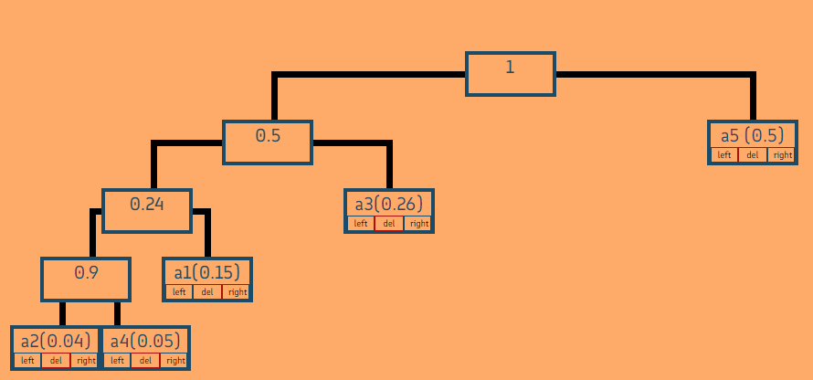
    - 0 is left, 1 is right
    - a₁ = 001
    - a₂ = 0000
    - a₃ = 01
    - a₄ = 0001
    - a₅ = 1
  - Average Length & Redundancy
    - HC(T) = ∑(p*r)
    - = [0.15 * 3] + [0.04 * 4] + [0.26 * 2] + [0.05 * 4] + [0.5 * 1]
    - = 0.45 + 0.16 + 0.52 + 0.2 + 0.5
    - = 1.83 bits rate
    - Redundancy = Entropy – BitRate
    - R = 1.83 - 1.817694 = 0.012306

- 3.8 (For Programs - use Filename, YourNameChapter3Q8, for source code and screenshot of outputs)
  - 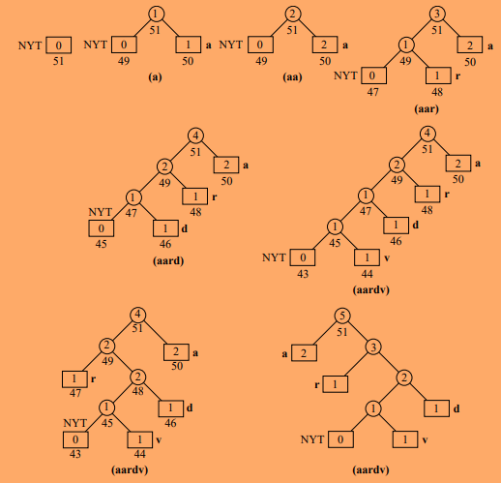
  - This is Example 3.4.1
  - +a
    - 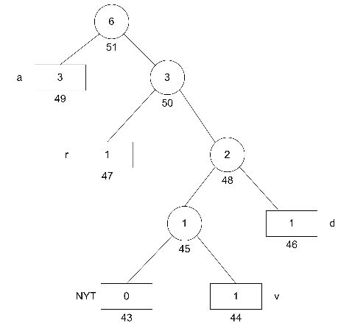
  - +r
    - 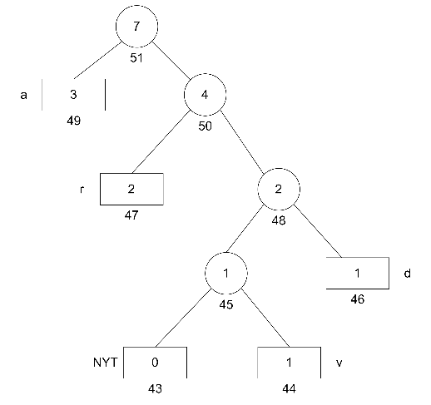
  - +k
    - 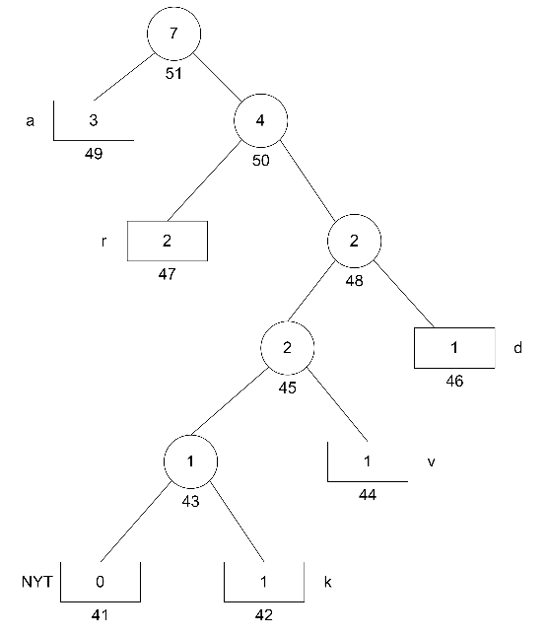
    - 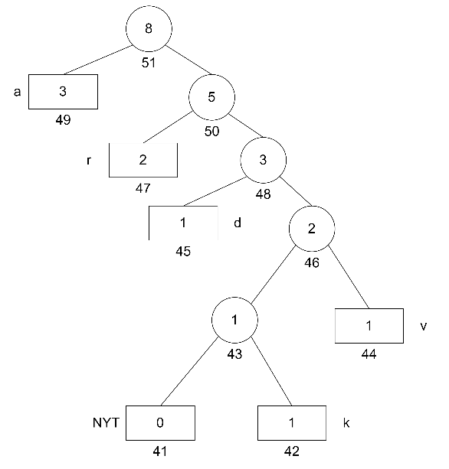

- 3.13 (For Programs - use Filename, YourNameChapter3Q13, for source code and screenshot of outputs)
  - Finding the iterations
    - N + K(N-1) <= 2^{N}
    - 3 + K(3-1) <= 2³
    - 3 + 2K <= 8
    - 2K <= 5
    - K <= 2.5
    - K = 2, so 2 iterations
  - Set-Up:
    - 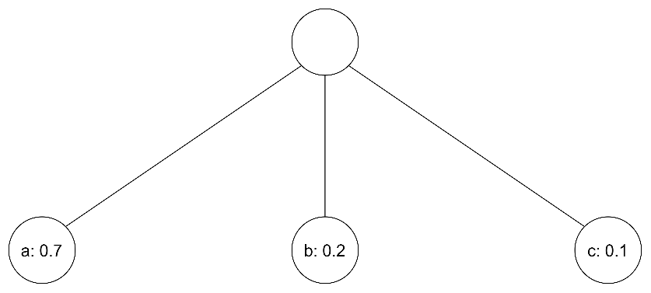
  - 1st iteration:
    - 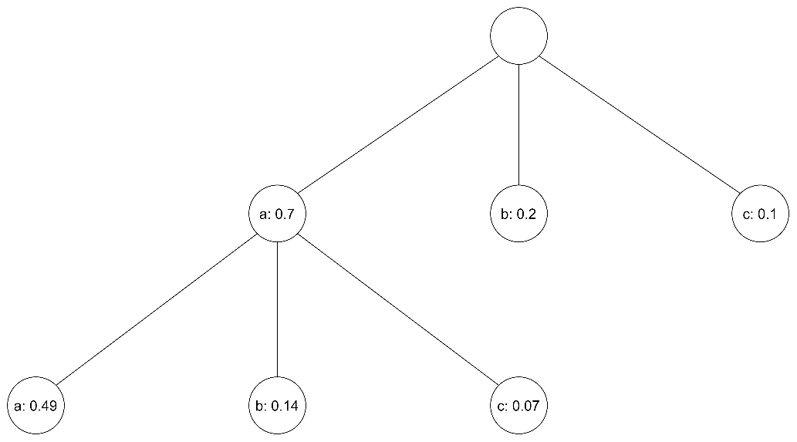
  - 2nd iteration:
    - 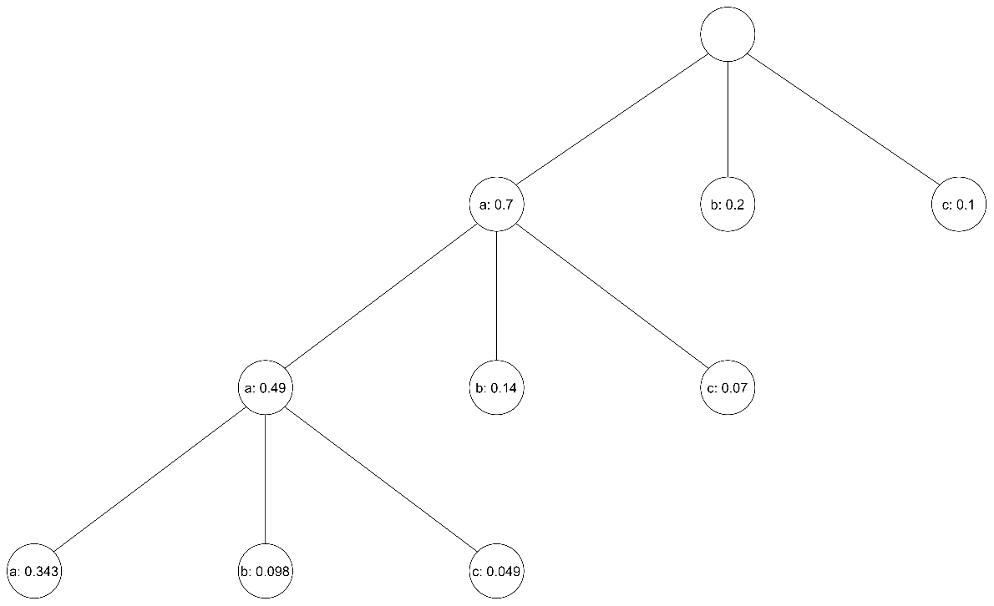
  - Generate the code
aaa | 000
aab | 001
aac | 010
ab | 011
ac | 100
b | 101
c | 110

Solve the following questions either manually or programming with Python/Java/C++.

Requirement:

In Cover Page or Program Comments at the top of each source code file, place the following:

<your name>

CPSC 4330/5330
Assignment Number: Questions Number:
Due: <as specified>
Submitted: <date>

[For Programs: brief description of the problem that the program was written to solve Additional documentation should follow the guidelines in the CS Department’s Programming Documentation Requirements, which can be accessed at http://cs.lamar.edu/Programming%20Documentation%20Requirements.pdf.

Please upload your source codes and screenshots of outputs on BlackBoard. ]

